

**Road Trip Scavenger Hunt**

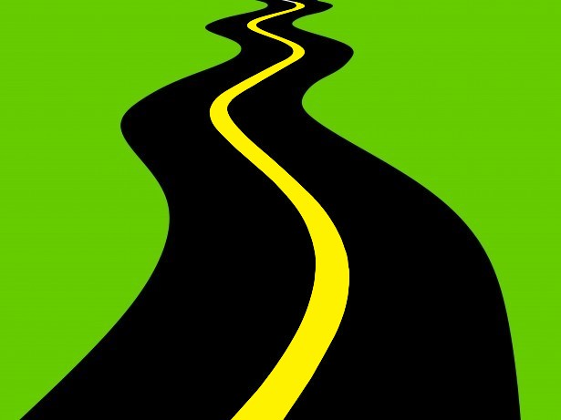

* Red Car
* Gas Station
* Bridge
* Yellow Car
* Cow
* Ambulance
* Bike
* Stop Sign
* Police Car
* Bus



* Truck
* Green Car
* Dog
* Horse
* Lake
* Church
* Blue Car
* American Flag
* Deer
* RV

